

S
-
100

Inland ECDIS and ECS
and Interoperability
Specification

Part B: Level 2 Interoperability

Edition

.

–

Permission number 11/2026
Material from IHO publication S-98 S-100 ECDIS and Interoperability Specification Edition 2.0.0 – October 2025 is reproduced with the permission of the IHO Secretariat (Permission No 11/2026) acting for the International Hydrographic Organization (IHO), which does not accept responsibility for the correctness of the material as reproduced: in case of doubt, the IHO’s authentic text shall prevail. The incorporation of material sourced from IHO shall not be construed as constituting an endorsement by IHO of this product.

iii
Contents
B-1 Introduction 1
B-1.1 How to read this Part 1
B-2 Specification Scope for Part B 1
B-3 Data Content and Structure 2
B-3.1 Application Schema 2
B-3.1.1 Overview of Application Schema 2
B-3.1.2 Operations in pre-defined combinations 3
B-3.1.3 Enhanced selection of feature instances 3
B-3.1.4 Interoperability levels 4
B-3.1.5 Hybridization rules 4
B-3.1.6 Hybrid Feature and Portrayal Catalogues 4
B-3.1.7 Progression of Interoperability Levels 4
B-3.2 Interoperability Catalogue 4
B-3.2.1 Conceptual types for Level 2 interoperability 4
B-3.2.2 Use of S-100 types 6
B-3.3 UML model documentation 6
B-4 Level-Specific Data Quality Considerations 7
B-4.1 Quality of displayed data 7
B-4.2 Quality of interoperability catalogues 7
B-4.2.1 Test methods 7
B-4.2.2 Data quality testing 7
B-5 Level-specific Guidance on Making Product Specifications Interoperable 7
B-5.1 Duplicated features 7
B-5.1.1 Duplicated features same model 8
B-5.1.2 Duplicated features, different models 8
B-5.1.3 Duplicate feature domains 8
B-5.2 Geometry 8
B-5.2.1 Combined geometry 8
B-5.2.2 Spatial discrepancy, unrelated to scaled or cartographic smoothing 8
B-5.2.3 Spatial discrepancies, related to scale or cartographic smoothing 8
B-5.3 Display of text 8
B-5.4 Skin-of-the-earth feature operations 9
B-5.4.1 Skin-of-the earth feature replacement 9
B-5.4.2 Skin-of-the earth feature adjusting 9
B-5.5 Blended feature concepts 9
B-5.6 Hierarchy of data 9
B-5.6.1 Hierarchy by stacking of display planes 9
B-5.6.2 Predefined combinations 9
B-5.7 New datasets 9
B-5.8 Dataset scales, loading, and unloading 9
B-5.9 Metadata 10
B-5.10 Meta-features 10
B-5.11 Quality considerations 10
B-6 Portrayal 10
B-6.1 Display of significant features 10
B-6.2 Display of significant features - switching to original 10
B-6.3 Portrayal distinguishability - colour set-asides 10
B-6.4 Day/night/dusk modes 10
B-6.5 Impacts on viewing groups 11
B-6.6 Impacts on Portrayal Catalogues 11
B-6.7 Meta-features 11
B-6.8 Display of text 11
B-6.9 Skin-of-the-earth operations and portrayal 11
B-6.9.1 Skin-of-the-earth feature replacement and portrayal 11
B-6.9.2 Skin-of-the-earth feature adjusting and portrayal 11
B-6.10 Blended portrayals 12
B-6.11 Hierarchy of data 12
B-6.11.1 Interacting gridded information 12
B-6.12 Pick Reports 12
B-7 Processing Model 12
B-8 Normative Implementation Guidance 15
B-9 Feature Catalogue 15
B-10 Portrayal Catalogue 15

v
Document History
Changes to this Specification are coordinated by IEHG. New editions will be made available via the IEHG web site.
Version Number | Date | Approved By | Purpose
0.1

Page intentionally left blank

B-1 Introduction
S-403 Part B contains information that applies to Interoperability Catalogues which use interoperability rules and operations of at most Level 2 interoperability.
Interoperability Catalogues conforming to this Part must comply with both the following components of S-403:
- S-403 Main Specification, which describes requirements applying to all S-403 Interoperability Catalogues and S-403 Exchange Sets;
- S-403 Part B (this Part), which defines the subset of the interoperability model and Catalogue encoding that are specific to Level 2 interoperability.
The hypothetical processing model for implementations is described in general terms in the “S-403 - Main” document and elaborated in clause B-B-7 of this Part.
Level 2 interoperability includes the following capabilities:
- Level 1 interoperability, in which feature types from different products, including S-401, are interleaved as specified by display plane and drawing priority information contained in the Interoperability Catalogue.
- In addition, Level 2 allows suppression of all features of a specified feature type in a specified product, with another feature type from a different product being displayed instead. Filtering by attribute values and geometry type is also possible.
- Level 2 also adds constructs allowing Catalogues to partition interoperability rules and operations according to specified combinations of data products (“predefined combinations”). The rules and operations in each partition are applied only when the corresponding data products are part of the display.
The output of interoperability processing is either the original feature data (processing option 1) or drawing instructions (processing option 2), accompanied by display plane and drawing priority information, which is passed through to the portrayal processor. Clause B-7 elaborates on these options.

B-1.1 How to read this Part
Clause B-2 of this Part contains scope identification information corresponding to the contents of this Part, which applies specifically to Interoperability Catalogues designated as Level 2.
For Clauses B-3–B-10, the content of the clause or sub-clause extends or elaborates on the content under the same or similar clause heading or sub-heading in the S-403 – Main document.
The numbering of clauses B-3–B-10 may differ from that of corresponding clauses in S-403 – Main, because for some there is no additional Level-specific information needed. If a clause or sub-clause in S-403 – Main has no corresponding clause or sub-clause in this Part, there is no Level-specific information on that topic.
Part B includes Part A content (pertaining to Level 1), adapted as necessary for Level 2. Reference to Part A should therefore not be needed.

B-2 Specification Scope for Part B
S-403 Part B describes the portions of S-98 which correspond to the following scope defined in S-403 – Main (clause 2):

Scope Identification: S403L2
Level: MD_ScopeCode – 13 (software)
Level Name: Interoperability Level 2
Description: Type-based selectivity and feature class replacement; interleaving
Extent: EX_Extent.description = “worldwide”; EX_GeographicBoundingBox = [-180, +180, -90, +90]

B-3 Data Content and Structure

B-3.1 Application Schema

B-3.1.1 Overview of Application Schema
The Application Schema for Interoperability Level 2 is depicted in Figure B-3.1 below. This Application Schema is a subset of the full Application Schema in S-100 Part 16. It consists of the following components:
- Catalogue header information.
- Display plane ordering information.
- Display planes content in the form of either features or drawing instructions.
- Specification of rules indicating which feature layers to suppress.
- Specification of data product combinations and method of referencing collections of interoperability rules and operations to specific combinations.
- Specification of rules indicating which feature instances to suppress.

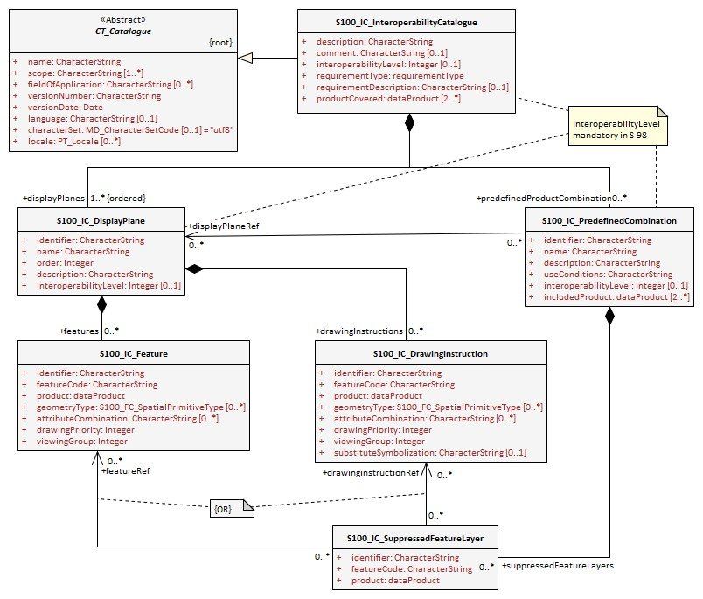
Figure B-3.1 – Level 2 Interoperability Catalogue

B-3.1.2 Operations in pre-defined combinations
Level 2 introduces predefined combinations, whereby the scope of specified interoperability operations can be restricted so the operations are executed only when a specified set of data products is active on the user display. Display plane and feature ordering (Level 1 operations) can be thus restricted by associating a specific set of products (listed in S100_IC_PredefinedCombination elements) to S100_IC_DisplayPlane elements.
Level 2 interoperability also allows replacement of a feature layer from one product by a feature layer from another product. These layers are specified by S100_IC_SuppressedFeatureLayer elements. Replacement operations are restricted to occur only when specific combinations of data products are present on the user display because the S100_IC_SuppressedFeatureLayer elements in Interoperability Catalogues are always contained within S100_IC_PredefinedCombination elements.

B-3.1.3 Enhanced selection of feature instances
Enhanced selection of feature instances is possible only in Levels 3 and 4 (Parts C and D).

B-3.1.4 Interoperability levels
The interoperabilityLevel attribute in S100_IC_InteroperabilityCatalogue specifies the highest Level of interoperability implemented in that XML Interoperability Catalogue file. The interoperabilityLevel attribute in S100_IC_DisplayPlane specifies the Level to which that display plane pertains.
The interoperabilityLevel attribute in each S100_IC_PredefinedCombination element specifies the highest Level of interoperability operations that are encoded in the element. S100_IC_PredefinedCombination elements are permitted to also include operations of a lower Level of interoperability.

B-3.1.5 Hybridization rules
Hybridization rules are allowed only in Levels 3 and 4 (Parts C and D).

B-3.1.6 Hybrid Feature and Portrayal Catalogues
Hybrid Feature and Portrayal Catalogues are allowed only in Levels 3 and 4 (Parts C and D).

B-3.1.7 Progression of Interoperability Levels
Figure B-3.2 below shows the components of the model subset used by this Level compared to lower Levels.
Level 2 adds predefined combinations and feature suppression elements to Level 1.
Interoperability Catalogues at any Level can also use lower-Level functionality.
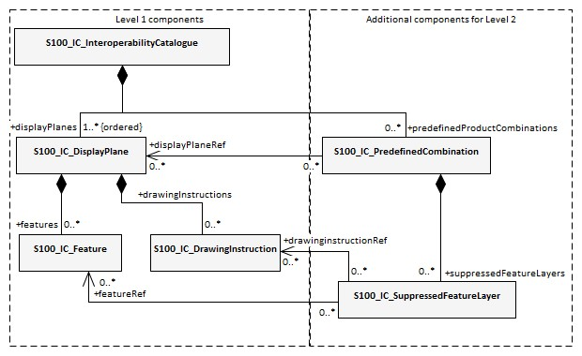
Figure B-3.2 - Progressive use of Interoperability Catalogue model

B-3.2 Interoperability Catalogue

B-3.2.1 Conceptual types for Level 2 interoperability
The following clauses summarize the conceptual elements used in Level 2 Interoperability Catalogues. Details about these conceptual types are provided in S-100 Part 16.

B-3.2.1.1 Display plane (S100_IC_DisplayPlane)
A display plane element in the Interoperability Catalogue acts as a container for display information for specified feature classes, which enables the interleaving of feature layers during portrayal by indicating the display plane, priority, and drawing order of the features assigned to a display plane.
A feature type may be referenced in more than one S100_IC_DisplayPlane, but the entries in different display planes must be distinguished by different attribute-value combinations or spatial primitives so that the actual instances of features are partitioned unambiguously between different display planes.
The portrayal of feature types not mentioned in any S100_IC_DisplayPlane component is undefined until ordinary portrayal processing takes place.

B-3.2.1.2 Feature type display information (S100_IC_Feature)
The S100_IC_Feature element describes the display parameters for all features of a specific feature type in a specific product and thereby determines the order of drawing the feature type relative to other feature types in the same display plane. It also specifies the viewing group to which the feature is assigned. Its applicability can be optionally restricted to a subset of instances of the feature type by additional attributes that specify the type of spatial primitive and indicate specific values of thematic attributes.

B-3.2.1.3 Feature layer (S100_IC_SuppressedFeatureLayer)
Each instance of this element identifies a feature type in a specific data product which is supposed to be suppressed in the presence of another specified feature type from another product.

B-3.2.1.4 Drawing instruction (S100_IC_DrawingInstruction)
Drawing instructions in the Interoperability Catalogue play a similar role to feature type display information
(S100_IC_FeatureType) but with drawing instructions instead of feature objects. The
S100_IC_DrawingInstruction element in Interoperability Catalogues is similar in operation to the layering and priority aspects of the DrawingInstruction element in Portrayal Catalogues (see S-100 Part 9 - Portrayal). Where there is a conflict with a Portrayal Catalogue drawing instruction, the drawing instruction in the Interoperability Catalogue supersedes the drawing instruction in the Portrayal Catalogue.
The S100_IC_DrawingInstruction element contains an additional attribute that allows substitution of symbolization instructions generated by portrayal processing.

B-3.2.1.4.1 Comparison and use of S100_IC_Feature and S100_IC_DrawingInstruction
S100_IC_Feature and S100_IC_DrawingInstruction elements in Interoperability Catalogues operate in essentially the same way as far as assignment of drawing order, priority, and display planes is concerned. They differ in that S100_IC_DrawingInstruction provides an optional attribute to substitute the symbolization elements of the drawing instruction.
S100_IC_Feature should be used for Interoperability Catalogues that are designed for systems where interoperability processing precedes the generation of drawing instructions.
S100_IC_DrawingInstruction should be used for Interoperability Catalogues that are designed for systems where interoperability processing precedes the generation of drawing instructions. It should also be used in all Catalogues where substitution of symbolization is necessary.

B-3.2.1.5 Predefined combination (S100_IC_PredefinedCombination)
A predefined combination element defines a collection of data products for which a common set of interoperability operations have been defined in the Interoperability Catalogue. Instances of predefined combinations are also characterized by interoperability Level, which allows the encoding of different sets of operations depending on how tightly integrated the user desires the products to be on the resultant display.
The interoperabilityLevel attribute in each S100_IC_PredefinedCombination element specifies the highest Level of interoperability operations that are encoded in the element. S100_IC_PredefinedCombination elements with a specified Level attribute are permitted to also include operations of a lower Level of interoperability.
Predefined combinations can be linked to S100_IC_DisplayPlane elements by means of references in the S100_IC_PredefinedCombination elements.

B-3.2.2 Use of S-100 types
The S-100 types used by S-403 Level 2 Interoperability Catalogues are described in the S-403 – Main document. For Level 2 Interoperability Catalogues, the following additional information applies.
• Interoperability Catalogues of Level 2 do not use feature and information associations in feature filters.

B-3.3 UML model documentation
The UML model documentation is provided in S-100 Part 16. This clause documents details specific to the use of the UML model for the interoperability Level described in this Part of S-403.
Only the model elements used in this Level (and included in the Level’s Application Schema) are listed. The constraints and considerations listed in the UML documentation tables in S-100 Part 16 apply. Any S-403 general or Level-specific considerations are described under the element name in the list below.
- S100_IC_DisplayPlane: No Level-specific constraints or notes.
Attribute interoperabilityLevel: Mandatory. The only values allowed for Level 2 Interoperability Catalogues are 1 and 2.
- S100_IC_DrawingInstruction:
NOTE for implementers: Even if the Presentation Schema in S-100 Part 9 is used, implementers may need to provide specific code to validate the content of the substituteSymbolization attribute instead of depending on normal XML Schema validation. The content of this attribute is not prescribed by this Specification and may be a fragment of XML, or interpretable code or rules, etc, in a non-XML syntax. It may be enclosed in a <![CDATA[ … ]]> section so that XML validators treat it as character data instead of XML.
- S100_IC_Feature: No Level-specific constraints or notes.
- S100_IC_InteroperabilityCatalogue:
Attribute productCovered: Must use values defined in the dictionary identified by MRN: urn:mrn:iehg:prod:s403:1:0:0:products.
Attribute interoperabilityLevel: Mandatory in S-403 Catalogues at all Levels. The only value allowed for Level 2 Interoperability Catalogues is 2.
- S100_IC_PredefinedCombination:
Attribute interoperabilityLevel: Mandatory in S-403 Interoperability Catalogue; allowed values: 1, 2.
- S100_IC_SuppressedFeatureLayer: No Level-specific constraints or notes.
- Codelist dataProduct: No Level-specific constraints or notes. The data type for all Levels is described below.
Codelist Type: closed dictionary
MRN: urn:mrn:iehg:prod:s403:1:0:0:products.
- Codelist requirementType: No Level-specific constraints or notes.
For all interoperability Levels, the following subset of the standard values listed in S-100 Part 16 are permitted to be used in S-403 Interoperability Catalogues:
Table B-3-1 - Allowed values for requirementType
Value | Description | Code
IEHG | Original IEHG Interoperability Catalogue | 1
OEM | Prepared according to requirements specified by OEM or systems integrator | 2
national | Prepared according to requirements specified by a national Government, group of national Governments (for example the European Union), or governmental agency such as a national shipping authority or the Coast Guard | 3
local | Prepared according to requirements specified by a sub-national governmental authority such as a state, province, or county | 4
port | Prepared according to requirements specified by a harbormaster's office or port authority | 5
company | Prepared according to requirements specified by the owner, charterer, or operator | 6
pilot | Prepared according to requirements specified by a pilot | 7
master | Prepared according to requirements specified by the vessel’s master | 8

Extra values (“other: ...”) as defined in S-100 Part 3, clause 3-6.7 are also permitted.
- S100_IC_PredefinedCombination
Role derivedFeatures: Not allowed in Level 2 Interoperability Catalogues.

B-4 Level-Specific Data Quality Considerations

B-4.1 Quality of displayed data
There are no Level-specific extensions to clause 6.1 of the “S-403 – Main” document.
Clause B-B-5.111 provides guidance for maintaining data quality for Level-specific rules and operations.

B-4.2 Quality of interoperability catalogues
The quality measures recommended in S-97 (Part C) which are applicable to Level 2 S-403 Interoperability Catalogues are those listed in Table 6-1 of the “S-403 – Main” document. There are no additional Levelspecific measures for Level 2.

B-4.2.1 Test methods
There are no Level-specific extensions to Clause 6.2.1 of the “S-403 – Main” document.

B-4.2.2 Data quality testing
There are no Level-specific extensions to Clause 6.2.2 of the “S-403 – Main” document.

B-5 Level-specific Guidance on Making Product Specifications Interoperable
The guidelines in this clause supplement and extend guidance common to all Levels on making Product Specifications interoperable, which is given in clause 8 of the “S-403 – Main” document.

B-5.1 Duplicated features
There is no Level-specific guidance for determining duplicated features. However, when Interoperability Catalogues are developed to resolve duplicated features, keep in mind the following Level-dependent considerations:
Level 2 Interoperability Catalogues offer the following interoperability functionality:
- Interleaving changes - changes to the display planes and display orders specified in the products’ Portrayal Catalogues, as determined by display plane and drawing priority information. This means that features which are not covered by features with higher drawing priority or in an upper display plane will still be visible. This is the same functionality as Level 1.
- Type-based suppression of features from one product by features from another product. The difference from interleaving changes is that type-based suppression will suppress even features which are not covered by features from the second product. Note that this applies only in areas where there is data coverage by both products; it does not apply in areas where only one product has data coverage. This functionality is added in Level 2.

B-5.1.1 Duplicated features same model
See the guidance in clause 8.1.1 of the “S-403 – Main” document, and keep in mind the differences between Level 1 and Level 2 interoperability solutions described earlier in clause B-5.1 of this Part.
S100_IC_SuppressedFeatureLayer elements only have feature code and product as attributes for suppression, this means that all instances of a listed feature class will be suppressed. This is important to remember when creating rules that promote alternative instances. S100_IC_Feature and S100_IC_DrawingInstruction can have attribute combinations and spatial primitives to select the alternative instances. There is therefore a risk that unless sufficient attention to detail is given, important instances may be omitted.
EXAMPLE: If Restricted Area Navigational in IENC is suppressed, and Restricted Area Navigational with attribute category of restricted area = 4 (nature reserve) in a Marine Protected Area dataset is promoted in its place, there is a chance that only instances with that combination will be visible, and all others supressed.

B-5.1.2 Duplicated features, different models
See the guidance in clause 8.1.2 of the “S-403 – Main” document, and keep in mind the differences between Level 1 and Level 2 interoperability solutions described in clause B-5.1 of this Part. There is no other Levelspecific guidance for this scenario.

B-5.1.3 Duplicate feature domains
See the guidance in clause 8.1.3 of the “S-403 – Main” document, and keep in mind the differences between Level 1 and Level 2 interoperability solutions described in Clause B-5.1 of this Part. There is no other Levelspecific guidance for this scenario.

B-5.2 Geometry

B-5.2.1 Combined geometry
Combined geometry is possible only in interoperability Levels 3 and 4 (Parts C and D of this Specification).

B-5.2.2 Spatial discrepancy, unrelated to scaled or cartographic smoothing
There is no Level-specific guidance for this issue. Common guidance is provided in clause 8.2.2 of the “S-403 – Main” document.

B-5.2.3 Spatial discrepancies, related to scale or cartographic smoothing
There is no Level-specific guidance for this issue. Common guidance is provided in clause 8.2.3 of the “S-403 – Main” document.

B-5.3 Display of text
There is no Level-specific guidance for this issue. Common guidance is provided in clause 10.8 of the “S-403 – Main” document.

B-5.4 Skin-of-the-earth feature operations

B-5.4.1 Skin-of-the earth feature replacement
Level 2 Interoperability Catalogues permit any of the following:
- Interleaving of display planes so that upper planes overwrite lower planes (Level 1 functionality). This can be used to shift feature layers to lower or higher planes to overwrite layers whose replacement is desired.
- Suppression of feature layers in which case the features in the suppressed layer are not processed for portrayal but features over/under the suppressed features will be displayed as determined by their display planes and drawing priorities (Level 2 functionality).
See clause B-6.9 for portrayal considerations.

B-5.4.2 Skin-of-the earth feature adjusting
Adjustment of the geometry of skin-of-the-earth features is possible only in Level 4 (Part D).

B-5.5 Blended feature concepts
Blended features or blended portrayal are only possible in interoperability Levels 3 and 4 (Parts C and D).

B-5.6 Hierarchy of data

B-5.6.1 Hierarchy by stacking of display planes
In Level 2 Interoperability Catalogues, hierarchy can be set by interleaving of display planes or feature layer suppression operations.

B-5.6.2 Predefined combinations
Predefined combinations can be defined in Level 2 Interoperability Catalogues. Interoperability rules can be made contingent on the presence of particular combinations of data products on the display. Predefined combinations are generally created with a particular type of operational view in mind, and therefore the hierarchy of data may vary between predefined combinations. Typically, the IENC will be the base layer; that is, the lowest layer in a predefined combination.
Predefined combinations are used to define the hierarchy of data between different S-100 based Specifications. An instance of S100_IC_PredefinedCombination is associated to S100_IC_DisplayPlane instances to give the hierarchy of the data products that are intended to be used. The attribute order within the S100_IC_DisplayPlane gives the order in which the layers are drawn.

B-5.7 New datasets
There is no Level-specific guidance for this issue. Common guidance is provided in clause 8.7 of the “S-403 – Main” document.

B-5.8 Dataset scales, loading, and unloading
There is no Level-specific guidance for this issue. Common guidance is provided in clause 8.8 of the “S-403 – Main” document.

B-5.9 Metadata
There is no Level-specific guidance for this issue. Common guidance is provided in clause 8.9 of the “S-403 – Main” document.

B-5.10 Meta-features
Any spatial operations on meta-features require an Interoperability Catalogue to implement at least Level 4.
There is no other Level-specific guidance for meta-features. Common guidance is provided in clause 8.10 of the “S-403 – Main” document.

B-5.11 Quality considerations
There is no Level-specific guidance for this issue. Common guidance is provided in clause 8.11 of the “S-403 – Main” document.

B-6 Portrayal
This clause gives guidelines and instruction to portrayal considerations related to the use of the
Interoperability Catalogue in an Inland ECDIS and ECS. The Interoperability Catalogue must apply to the specific Product Specifications listed in the Interoperability Catalogue metadata, interoperabilityCatalogueProducts attribute under S100_IC_CatalogueMetadata.
There may be additional data products present in the S-100 Inland ECDIS and ECS that are external to the Interoperability Catalogue; in such cases the Interoperability Catalogue should continue to function in presence of products not defined in the Catalogue. Data products that are outside of the interoperability scope must be treated in Interoperability Level 0 (see clause 9.6 in the “S-403 – Main” document).

B-6.1 Display of significant features
There is no Level-specific guidance for this issue. Common guidance is provided in clause 10.1 of the “S-403 – Main” document.

B-6.2 Display of significant features - switching to original
There is no Level-specific guidance for this issue. Common guidance is provided in clause 10.2 of the “S-403 – Main” document.

B-6.3 Portrayal distinguishability - colour set-asides
There is no Level-specific guidance for this issue. Common guidance is provided in clause 10.3 of the “S-403 – Main” document. See also S-100 Part 16 for specific guidance on colour set-asides.

B-6.4 Day/night/dusk modes
There is no Level-specific guidance for this issue. Common guidance is provided in clause 10.4 of the “S-403 – Main” document.

B-6.5 Impacts on viewing groups
There is no Level-specific guidance for this issue. Common guidance is provided in clause 10.5 of the “S-
403 – Main” document.

B-6.6 Impacts on Portrayal Catalogues
There is no Level-specific guidance for this issue. Common guidance is provided in clause 10.6 of the “S-403 – Main” document.

B-6.7 Meta-features
There is no Level-specific guidance for this issue. Common guidance is provided in clause 10.7 of the “S-403 – Main” document.

B-6.8 Display of text
There is no Level-specific guidance for this issue. Common guidance is provided in clause 10.8 of the “S-403 – Main” document.

B-6.9 Skin-of-the-earth operations and portrayal

B-6.9.1 Skin-of-the-earth feature replacement and portrayal
For all Levels, anything that replaces S-401 skin-of-the-earth features, will overwrite it by having a higher priority; that is, be drawn later. The major difference between the Levels is in the overwriting.
Interoperability operations in Level 2 can overwrite skin-of-the-earth features and everything else (by interleaving display planes so that upper planes overwrite lower planes). They can also suppress feature layers, in which case features over/under the suppressed features will be displayed as determined by their display planes and drawing priorities.
Gridded data will generally go over IENC and obscure IENC features, either all (interoperability Level 0) or specific features (interoperability Levels 1 or 2) depending on interoperability Level chosen, the predefined combinations or display plane of the features that are interacting.
EXAMPLE 1: High definition gridded bathymetry replaces (overwrite) depth area and depth contours, but soundings, aids to navigation, and obstructions are over the high definition bathymetry (interoperability Level 1).
EXAMPLE 2: Surface current gridded data goes over IENC and replaces all surface current features (interoperability Level 2).
NOTE: The safety contour comes from the IENC and is generated by the viewer system. This safety contour should be presented with highest priority when turned on by the user. OEMs are permitted to add additional safety contour functions; for example, generated from combining high definition gridded bathymetry (S-102) and S-104 input.

B-6.9.2 Skin-of-the-earth feature adjusting and portrayal
This clause covers the possibility of the skin-of-the-earth feature geometry and/or attribute values being dynamically adjusted based on the corresponding features in other data layers.
Changes to the location or extent of symbols displayed on the screen due to a feature in another dataset are only possible in interoperability Levels 3 and 4 (Parts C and D).

B-6.10 Blended portrayals
There is no Level-specific guidance for this issue. Common guidance is provided in clause 10.10 of the “S-403 – Main” document.

B-6.11 Hierarchy of data

As noted in clause 11.11 of the “S-403 – Main” document, hierarchy of data can be controlled by predefined combinations. There is no Level-specific guidance for portrayal in connection with this issue.

B-6.11.1 Interacting gridded information
There is no Level-specific guidance for portrayal in connection with this issue. Common guidance is provided in clause 10.11.1 of the “S-403 – Main” document.

B-6.12 Pick Reports
[NOTE: The Pick Report functionality specification in S-98 is still under development, and the content of this section will change as this functionality is defined.]

B-7 Processing Model
Figure B-7.1 below shows the processing steps and input to each step from parts of the Interoperability Catalogue, for the “Interoperability before portrayal” processing option. Figure B-7.2 shows the steps and inputs for the “Interoperability after portrayal” processing option. In both cases, the flow depends on the interoperability Level selected by the Mariner.
In Level 0 processing, interoperability is turned off and all data products loaded are passed through to S-100 Portrayal Processing to be portrayed as overlays to IENC data according to their individual Portrayal Catalogues.
In Level 1 processing, the only interoperability processing is interleaving of feature layers by means of display plane information, and Interleave Feature Layers is the only interoperability processing before feature data is passed to S-100 Portrayal Processing. The only input from the Interoperability Catalogue is display plane and drawing order information from S100_IC_DisplayPlane elements in the Catalogue.
In Level 2 processing, feature type suppression operations (stage Suppress Feature Types) precede interleaving operations.
Figures B-7.1 and B-7.2 depict two possible implementations, with the input to interoperability processing being either feature data or drawing instructions generated from feature data by (part of) portrayal processing.

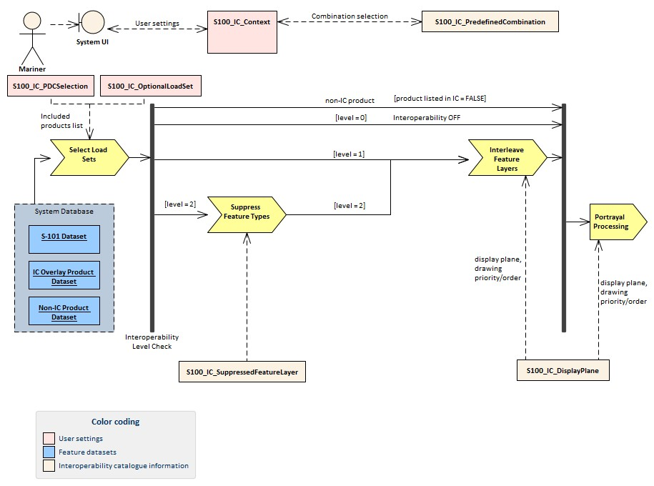
Figure B-7.1 - Interoperability processing flow (portrayal processing after interoperability)
For implementations that pass drawing instructions instead of features to interoperability processing, the flow is similar except that portrayal processing takes place before interoperability processing.
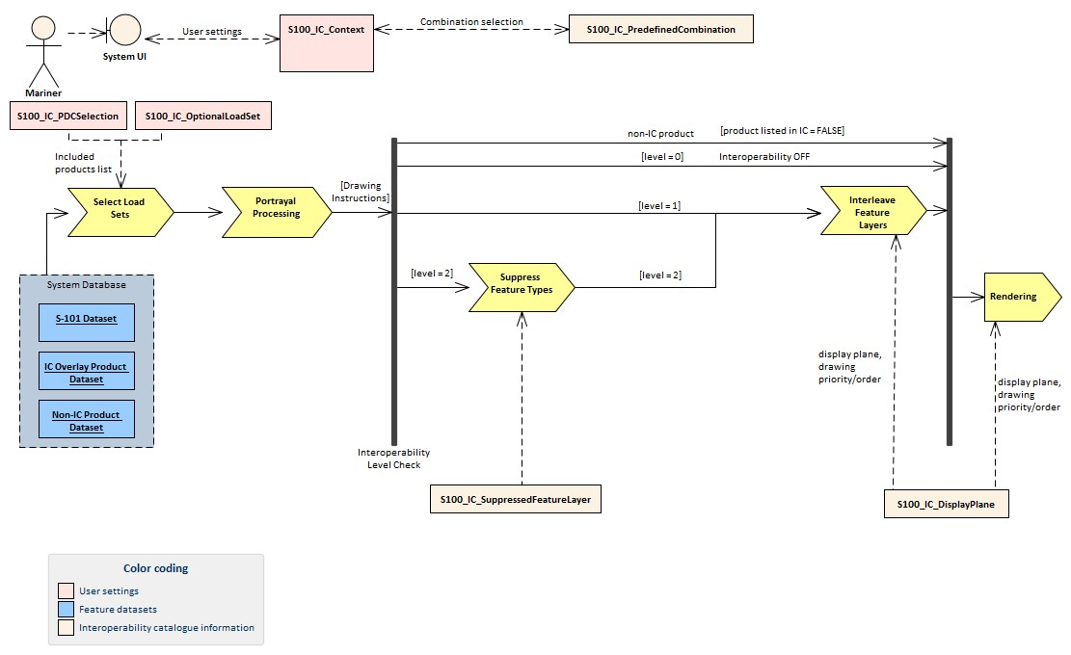
Figure B-7.2 - Interoperability processing (drawing instructions generated before interoperability processing)

Table B-7.1 - Stages in Level 2 interoperability processing
Stage | Description | Level | IC information | Context information | Remarks
Select Load Sets | Select data products to be loaded | All | Level 1: User adds data products to display individually  Level 2: Included product list from S100_IC_ PredefinedCombination. includedProduct | Level 1: None  Level 2: User-selected predefined combination | Information & functionality depends on whether user selects Level  1 or 2
Portrayal Processing | Ordinary S100 portrayal processing | All | display planes |  | Except final display processing / rendering
Interleave  Feature  Layers | Assign display plane and drawing order to feature data | 1, 2 | S100_IC_DisplayPlane
Suppress  Feature  Types | Suppress all instances of a specified feature type in a product | 2 | S100_IC_Suppressed FeatureLayer
Rendering | Display processing | All | S100_IC_DisplayPlane

B-8 Normative Implementation Guidance
There is no level-specific normative implementation guidance in this Edition of S-98. See clause 17 of the “S-98 – Main” document for implementation guidance that applies to all Levels.

B-9 Feature Catalogue
Level 2 does not define Feature Catalogues.

B-10 Portrayal Catalogue
Level 2 does not define Portrayal Catalogues.

Page intentionally left blank

